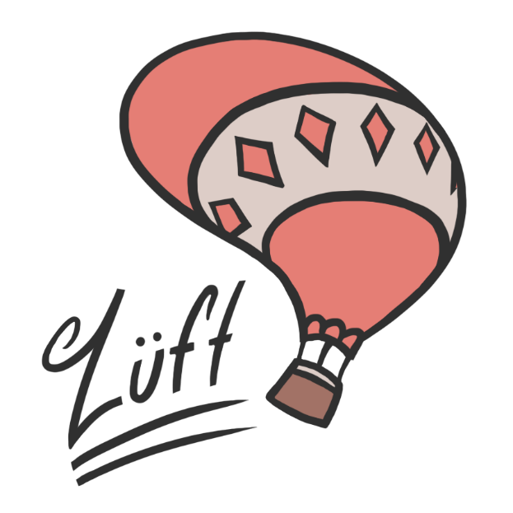
Figure 1: Luft Logo

Game Design Document
  - Suspended Disbelief Studios
  - Version 2.0
Position Title | Name | Signature
Asst. Game Designer | Tyler Morgan
Asst. Lead Level Designer | Katie Wood
Asst. Lead Programmer | Will Vennes
Asst. Lead Artist | Aaron Hamilton
Level Designer | Renan de Lima
Level Designer | Ross Shih Cheng
Programmer | Christian Walker
Artist | Baron Capers

Document Revisions Table
Version | Description | Requestor | Date
0.1 | Updated High Concept, Game Description, Gameplay Minute, Style, Story, Gameplay, Characters, World Layout, Level Description & Menus | Professor | 2/7/15
0.2 | Updated Level Descriptions | Professor | 2/9/15
1.0 | Proofread Document | Professor | 2/9/15
1.1 | Final Production Revision | Professor | 3/5/15
2.0 | Revised document to exclude alternate game mode, added in game pictures, and altered gameplay interactions | Professor | 4/27/15

Table of Contents
Table of Figures 5
Concept 6
High Concept 6
Game Description 7
Game Goals & Features 7
Story Synopsis 7
Game Pillars/Theme 7
Gameplay Minute 9
Capture the Flag 9
Style and Tone 11
Story/Backstory 11
Gameplay 12
Overview 12
Player’s Objective 12
Capture the Flag 12
Core Gameplay Mechanics 12
Camera 13
Controls 13
Player Movement/Interactions 15
Health System 15
Checkpoint System 15
Weapons System 16
Pickups System 18
Objects System 19
Environmental Objects 19
Key Objects 25
HUD 26
Characters 27
Team Two 27
World Layout 28
Game World Overview 28
Level Descriptions 28
Vanilla CTF Level: Twin Windmills 28
Vanilla CTF Level: Cloud City 28
Menu System 29
Installation 29
Title Splash Screens 32
Main Menu 35
Options Screen 36
Pause/Exit Screen 37
Game Over Screen 37
Credits Screen 39

Table of Figures

Figure 1: Luft Logo 1
Figure 2: High Concept Illustration² 6
Figure 3: Windmill Landmark 19
Figure 4: Ropes, lights, tulips, and other clutter 20
Figure 5: Tavern Clutter 20
Figure 6: Jump Pad 22
Figure 7: Hot air balloons 22
Figure 8: Buildings elements 24
Figure 9: HUD 26
Figure 10: Team colors 27
Figure 11: Menu System 29
Figure 12: Installer Icon 29
Figure 13: Luft Setup Wizard 31
Figure 14: Guildhall Splash Screen 32
Figure 15: Unreal Splash Screen 33
Figure 16: Suspended Disbelief Splash Screen¹ 34
Figure 17: In Game Menu 35
Figure 18: Options Screen 36
Figure 19: Controls 36
Figure 20: Pause Screen 37
Figure 21: Victory Screen 37
Figure 22: Defeat Screen 38
Figure 23: Credits 39

Concept

High Concept
Luft is a highflying multiplayer First Person Shooter. Balloon characters fight in and around a classical Swiss village suspended in the clouds using a variety of unique weaponry. It features a lighthearted tone combined with beautiful vistas, an original theme, and accessible gameplay.
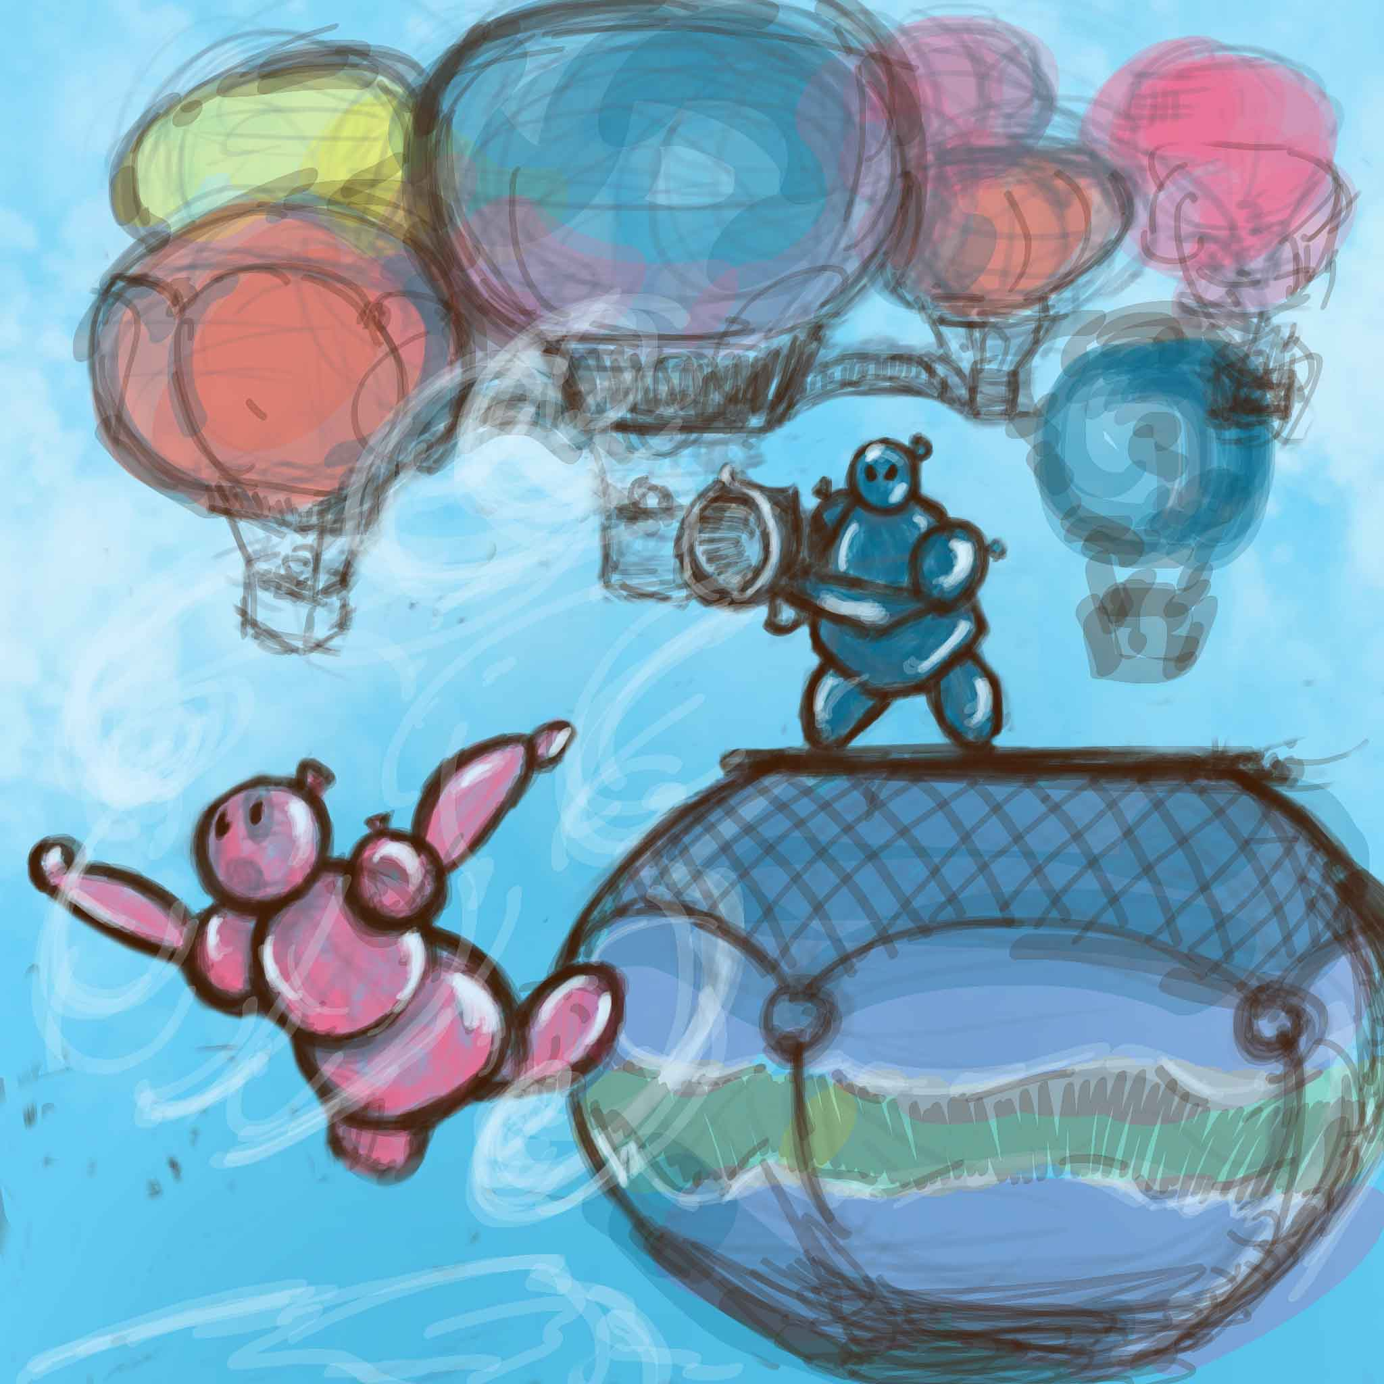
Figure 2: High Concept Illustration²

Game Description

Game Goals & Features
In Luft, players take control of two opposing teams of balloon-people engaged in friendly competition. It is a multiplayer, first person shooter with a single game mode, Capture the Flag. Capture the Flag mode consists of two opposing teams seeking to capture the other team’s flag and return it to their base.
Luft consists of several unique gameplay mechanics that players utilize during play. A major mechanic is the Luftkanon, an air gun that blows blasts of air out in front of it. Players use this blast of air to push players off the map and into hazards. They can also use the blast to launch themselves into the air, and have some degree of air control while midair. The player uses this gun to interact with other weapons as well, such as the ability to push balloon bombs placed on the map into other players. The game also consists of “floaty” physics, which reflects the material and makeup of the player character.

Story Synopsis
With the creation of the hot air balloon, a new option for travel previously unfathomable became available to isolated European villages. Enchanted by the large, floating vehicles, townspeople quickly took to the skies. Inspired, several Swiss villagers undertook construction of a balloon-based companion. These semi-intelligent canvas creatures, nicknamed “Balloon Buddies,” functioned as balloon ride companions and pilots. However, as the Balloon Buddies began frequently bobbing about, the villagers grew envious. They also desired to fly amongst the clouds. In a moment of impulse, the townspeople attached large balloons to several of their structures. Subsequently, these buildings lifted into the air, forming “sky villages.”
A hundred years have passed since this miraculous migration. To celebrate the formation of the balloon companions and balloon supported community, the sky village leaders decided to hold an amicable competitive event. Floating settlements from across Europe brought teams of Balloon Buddies to battle in “Capture the Flag” games. Luft portrays this festive tournament’s happenings through its setting, characters, and objective.

Game Pillars/Theme
Fun: The player’s moment-to-moment happiness is paramount in making a game that players enjoy. Therefore, every aspect of the game must contribute to this experience. Weapons are intrinsically fun to use, maps enjoyable to navigate even without opposition, and interesting interactions that keep the player coming back for more. This also means minimizing points of frustration, necessitating a smooth, clean user interface, low penalties for death, and balanced gameplay. These elements combine to create a game that is both enjoyable in small doses and gaming marathons.
Lighthearted: Luft’s buoyant tone colors the player’s expectations and gives the game its distinct character. Aesthetically it conveys a fanciful turn of the century village suspended in the clouds, replete with jauntily animated characters and lazily drifting environments. The game abstracts its violence with cartoonish weapons and silly death animations.
Accessible: It is vital that Luft be easy to pick up for a large range of ages. This means simple, intuitive controls and interactions that are natural and consistently applied. Luft clearly communicates gameplay objectives and provides the player with constant feedback through visuals, audio, and user interface.

Gameplay Minute

Capture the Flag
State | Description
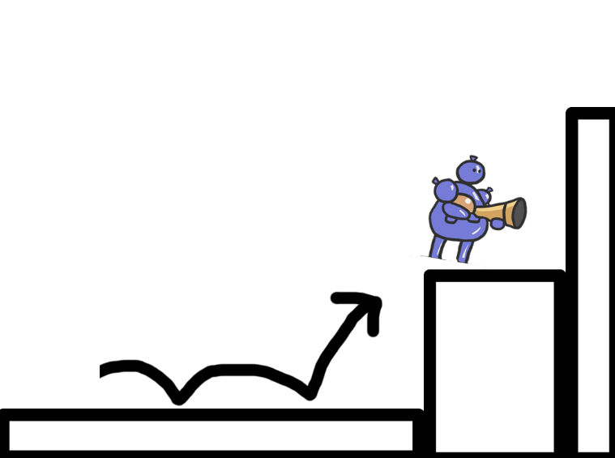 | Blue Team’s player advances and jumps to the next platform.
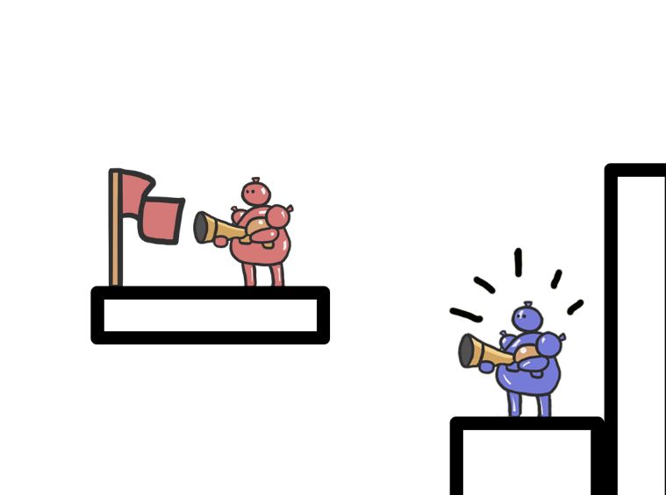 | Blue Team’s player sees the opponent by the flag. Red Team’s player does not notice the other player.
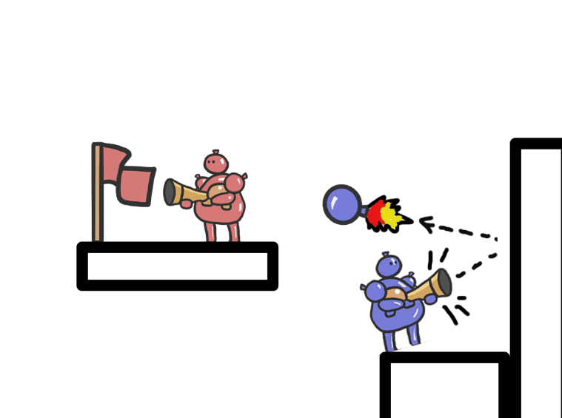 | Blue Team’s player shoots with the Bloonderbluss. The rocket balloon bounces at the wall.
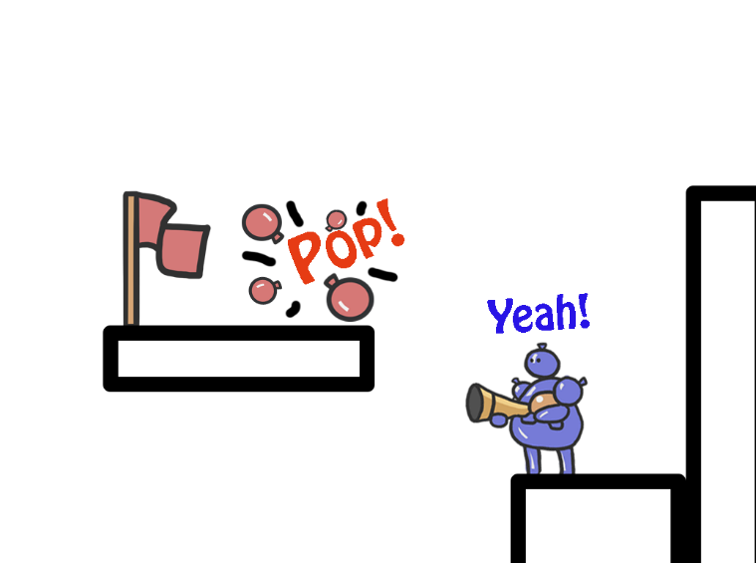 | The rocket balloon hits the Red Team’s player, who pops (dies).
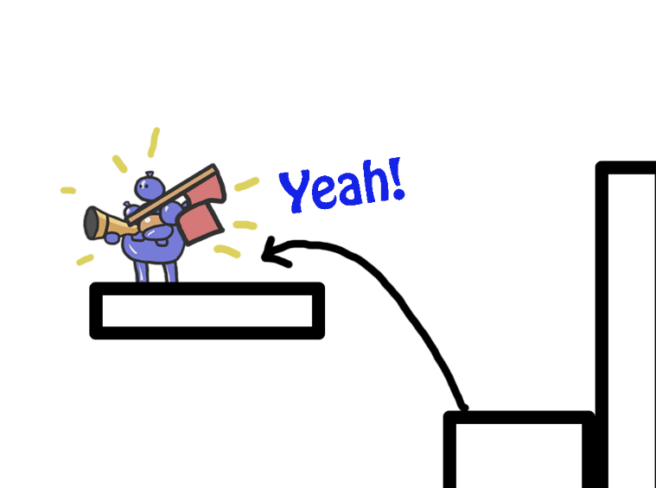 | With a clear path, the Blue Team’s player jumps to the next platform and captures the opponent’s flag.
Table 1: Capture the Flag Gameplay Minute

Style and Tone
Luft’s setting bases itself in the skies above late 19th century Switzerland. Luft portrays the tone of a fairy tale style fantasy. Beautiful Swiss buildings, windmills, bridges, and wooden platforms rest atop hot air balloons that float lazily in the sky. Lush green valleys, blue mountains, and puffy white clouds comprise the environment and atmosphere surrounding this floating arena. The visuals utilize a cartoon art style with exaggerated environment and character proportions, as well as hand painted textures to make the game feel like a colorful and friendly place. Upbeat Swiss folk style music plays in the background and the sound effects are goofy and embellished. The game achieves the look and feel of classical Switzerland while providing players with a fun gameplay experience through unique weapon mechanics and interesting visuals. This game evokes a happy, silly, and lighthearted emotion in players by providing them with a less serious and less violent take on the FPS genre. Players have the ability to traverse and explore this floating arena by jumping from balloon to balloon, building to building, as well as utilizing their Luftkanon to launch themselves far distances across the map. Luft distinguishes itself from the competition by exploring unique visual and atmospheric themes as well as weapon mechanics and team based competition to create a family friendly experience that players of all ages can enjoy.

Story/Backstory
Long ago, the first manned hot air balloon successfully traveled across the European countryside. To small, remote villages, this accomplishment promised access to previously unreachable areas. As villagers regularly began to soar above the clouds, they developed a deep fondness for the whimsical, colorful balloons. Due to this blooming admiration and affection, several Swiss citizens undertook development on a companion creature crafted from canvas and air. These inflatable pals, cleverly dubbed “Balloon Buddies,” traveled alongside the Swiss passengers, steering the air-fueled mode of transportation.
However, the Swiss villagers found themselves highly envious of their floating companions. To rectify this plight, the townspeople decided to attach massive balloons to their homesteads and landmarks. This ridiculous idea caused entire areas to bob up into the sky. The Balloon Buddies and the villagers lived harmoniously in the suspended villages. To celebrate their one hundredth year afloat, the sky villagers decided to hold a festival. On the day of the celebration, several villages send Balloon Buddy squads to compete in a friendly “Capture the Flag” tournament. This non-violent competition results in no deaths and winners achieve glory for their community until the next festival.
Luft conveys this backstory primarily through the incorporation of various aesthetic items. Tudor style buildings and windmills allude to the village’s European origins. Festive décor in the form of streamers, flags, and banners convey the festival’s purpose and existence. Hot air balloons attached to the floating sky villages reveal the town’s preference for the clouds above. However, decorative, artistic elements are not the only means Luft employs to enforce the narrative. The game’s overall objective, conveyed through HUD text, clearly reveals the Balloon Buddy teams’ motivations. Sound effects bolster this thematic objective.

Gameplay

Overview
Luft is a multiplayer FPS, revolving around Capture the flag. In Capture the Flag mode, two rival teams attempt to capture their opponent’s flag and return it to their base to score a point. The game ends when one team reaches the score limit of 5 points or when time runs out, at which point the team with the higher score wins.

Player’s Objective

Capture the Flag
- Capturing the opponent’s flag as many times as possible
- Protecting their own flag
Two rival teams attempt to steal their opponents flag and return it to their respective base. The teams’ unique colors coat these bases to allow instant recognition. Consequently, Luft’s arenas have primarily patterned and colored hot air balloons representative of the two participating teams. However, central areas are devoid of these denotations and instead have neutral markings.

Core Gameplay Mechanics
In Luft, players have access to three weapons, the Luftkanon, Bloonderbuss, and Pin Pusher, which interact in interesting ways. The first weapon is the Pin Pusher, a heavy magnum like pistol. It shoots extremely fast pin projectiles, which deal low damage, but fire quickly and through wind. Its alternate fire is a scope which narrows the player's field of view and changes the primary fire from a single shot to a short, controlled burst of pins.
The next weapon is the Bloonderbuss, a cannon which shoots a variety of balloon projectiles. Its primary fire is a fast moving balloon rocket, which ricochets off the environment. It deals high damage and a small amount of splash damage when it finally pops. Its velocity and elastic properties afford players possibilities for interesting trick shots, shooting enemies from around corners and from interesting angles, leading to fun, and chaotic gameplay. The alternate fire for the Bloonderbuss is a high damage balloon mine, which hovers in midair. Players can hold down the charge button to shoot the mine farther before it settles down. Players can use the Luftkanon to propel the mines at their enemies, or use the Pin Pusher to pop the mines from range, leading to interesting play and counterplay.
The final weapon is the Luftkanon, an air gun. The alternate fire for the Luftkanon is a short-range cone shaped blast of air, which grows in power the longer it has charged. The primary fire is a short burst of air tantamount to a Luftkanon blast charged for a second. The most obvious use for this weapon is offensive, pushing enemies back off ledges and away from important areas. However, players can also use it defensively, reflecting hostile projectiles and displacing harmful objects. Players can also use it to aid in movement, shooting the secondary fire downwards to propel themselves into the air, similar to a rocket jump in other games.
These three weapons form a rock paper scissors triangle of advantages. The Luftkanon can push the Bloonderbuss’ projectiles away, but is far too slow to deflect the projectiles of the Pin Pusher. The Bloonderbuss’ high damage shots can quickly overpower the Pin Pusher, but risks deflection from the Luftkanon.
The purpose of these mechanics is to create a simple, intuitive set of rules with a large variety of gameplay applications. The Luftkanon pushes balloons. Therefore, it pushes allies, enemies, and projectiles, all of which bear a similar aesthetic. The Pin Pusher pops balloons. Therefore, it hurts enemies and pops projectiles. These interactions make innate sense to anyone who has held a balloon, but create layers of strategic depth on top of simple and easy to learn gameplay.

Camera
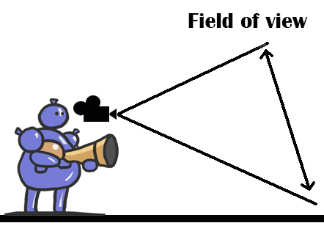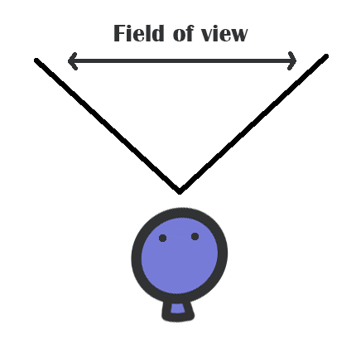
 | Description
Field of view | 106° on a 16:9 screen
Camera movement and motion | Using the W or S keys to move forward and backward  Using the A or D keys to strafe Left or Right  Using the Space key to Jump
Camera angles | The camera follows player’s mouse movement.  They can look around by moving the mouse.
Table 3: Field of view description

Controls
Key | Player Action
W | Move forward
S | Move backwards
A | Strafe left
D | Strafe right
Space | Jump
1 | Switch to Luftkanon
2 | Switch to Pin Pusher
3 | Switch to Bloonderbuss
Escape | Open menu
Left Mouse Button | Primary fire
Right Mouse Button | Alternate fire
Mouse Wheel Up | Switch to previous weapon
Mouse Wheel Down | Switch to next weapon
Table 5: Controls

Player Movement/Interactions
Interaction | Description
Environment | - When players fall off the edges of the playable area, they die.  - The Bloonderbuss shoots balloon projectiles, which bounce off of walls.  - The player can fire Luftkanon at ground to perform rocket jump to get to higher platforms or pass over gaps.
Combat | - The player holds the attack button to fire bullets.  - The player can also use Luftkanon to repel enemies and enemies’ projectiles.
Inventory | - The player can pick up weapons, ammunition, health pickups, armor, and power-ups.
Table 6: Player Movement/Interactions

Health System
Default health | 100 health
Death condition | The player dies if his health points become or go below 0.
Health restoration | The player gains health back when he picks up Bandages or Air tanks but cannot exceed 100 health.
Table 7: Health System

Checkpoint System
Whenever a player dies, he re-spawns at one of their team starting points after 3 seconds.

Weapons System
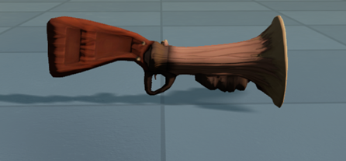  Bloonderbuss | Initial Ammo:  20  Max Ammo:  40 | Primary Fire  Deal 25 splash damage with a radius of 200 unreal units  - Fast moving balloon projectile  - Bounce off of walls  - Small splash damage  - 0.8 seconds between shots
Alternate Fire
Deal 60 splash damage
- Floating balloon mine
- Mines pushed by Air Gun
- Mines popped by Pin Pusher
- Launches out 3 meters in front of player
- Does not require reloading
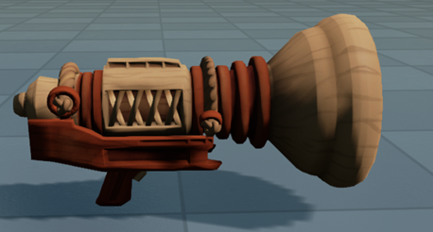  Luftkanon | Initial Ammo:  Infinite  Max Ammo:  Infinite | Primary Fire  Deal 0 damage  - Releases a blast of air in a block in front of the player  - Area of effect approximately 3 meters out with a 1x1 meter radius  - Knock enemies back up to 5 meters  - Deflect balloon projectiles  - Does not require reloading
Alternate Fire
Deal 0 damage
- Fires a direct blast of air
- Area of effect approximately 3 meters out with a 1x1 meter radius
- Charge to apply a greater force
- Knock back scales from 0 meters uncharged to a max of 30 meters.
- When fired at the ground allows players to rocket jump, also scaling based on time charged.
- Deflects balloon projectiles
- Does not require reloading

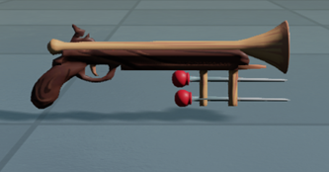  Pin Pusher | Initial Ammo:  40  Max Ammo:  80 | Primary Fire  Deal 15 damage per second  - Single shot with 0.4 seconds between each shot
Alternate Fire
60 damage per shot
- Take 1 second to reload
Table 8: Weapon Table

Pickups System
Health
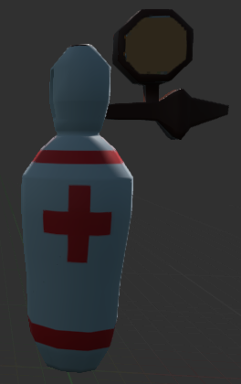 | Air Tank | Restore 10 health points (30 sec re-spawn)
Ammo
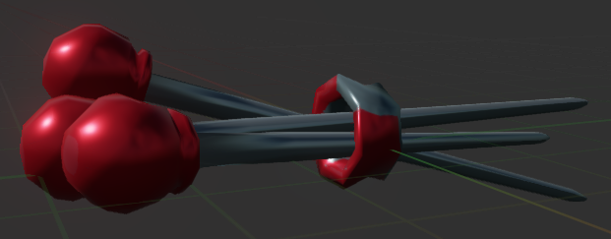 | Box of Needles | Refills 20 PinPusher's ammunition capacity (10 sec re-spawn)
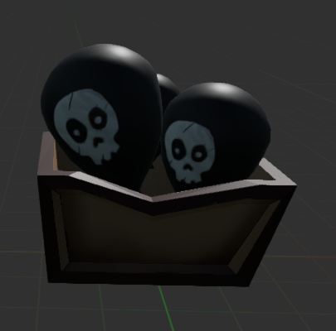 | Bundle O’ Bombs | Refills 10 Bloonderbuss's ammunition capacity (10 sec re-spawn)
Table 9: Pickup System

Objects System
Luft has two different categories for the objects: environmental and key objects. All of them have boundary boxes, which define their collision volumes, as either obstacles or triggers.

Environmental Objects
Environmental objects are game objects that build the game world, contributing to its either aesthetics, gameplay or story. They are present in Capture the Flag. This section breaks these elements down according to their functionalities in the game.

Landmarks
Landmarks are objects, which stand out among the other environmental elements, drawing the players’ attention and differentiating playable areas from each other. These objects are very large and only interact with the player in so far as they block off areas. Luft has two primary landmarks in each level, the brightly colored windmills on either side.
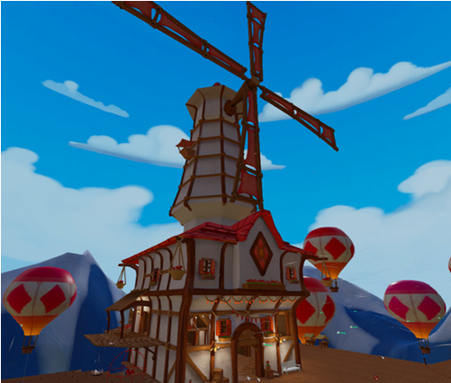
Figure 3: Windmill Landmark

Decoration
Decorative objects do not affect gameplay directly. Their goal is to contribute aesthetically to the theme and story, building a cohesive and consistent game world, to which the players invest themselves. Luft has trees, flowers and flowerpots as its purely decorative object (figure 4).
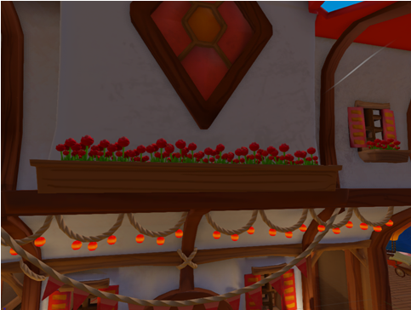
Figure 4: Ropes, lights, tulips, and other clutter
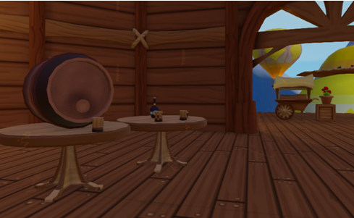
Figure 5: Tavern Clutter

Gameplay
Although gameplay objects also add to the aesthetic and decoration aspects of the game, they have a direct impact into the game, affecting the maps layout and lighting. The following table depicts the gameplay objectives according to their functions and locations – interiors or exteriors.
Location | Object | Description
Exterior | Large Hot Air Balloon | Hot air balloons which drift slowly up and down adding life and character to the environment
 | Floating villages | Small assemblies of buildings clustered together on rafts of balloons, filling out the environment
 | Wood Fans | Spread around the world, over buildings, and on top of balloons, the wood fans are small structures that blow the Balloon Buddies in specific directions, working as jump pads. The jump heights and directions are specific to the fan, varying along different instances of it
Table 3: Exterior objects that affect in gameplay

Figure 6: Jump Pad
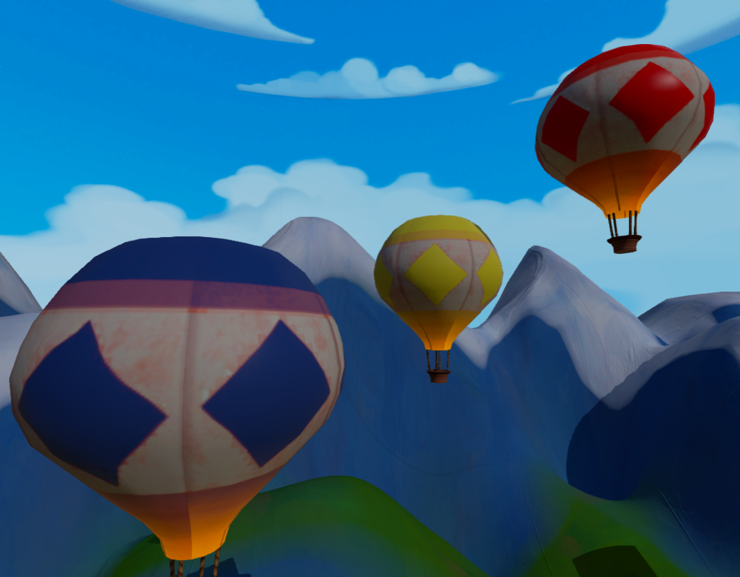
Figure 7: Hot air balloons

Location | Object | Description
Building elements | Buildings (floor, walls, ceilings, stairs, bridges, windows, pillars) | These elements define the levels’ geometry. They either block or facilitate player’s movement. Building elements, such as ceilings and walls, are used to detail interior spaces, while elements like stairs and bridges connect different areas, providing walkable paths for the players. These follow the Tudor style.
Interior/Exterior | Benches | These elements can either block the players’ path or provide cover for them. Player may also use them as small platforms to jump higher
 | Barrels
 | Crates
 | Lanterns | These serve as light sources and draw the player’s eye towards important locations.
Table 4: Building elements and objects that are present in exteriors and interiors.
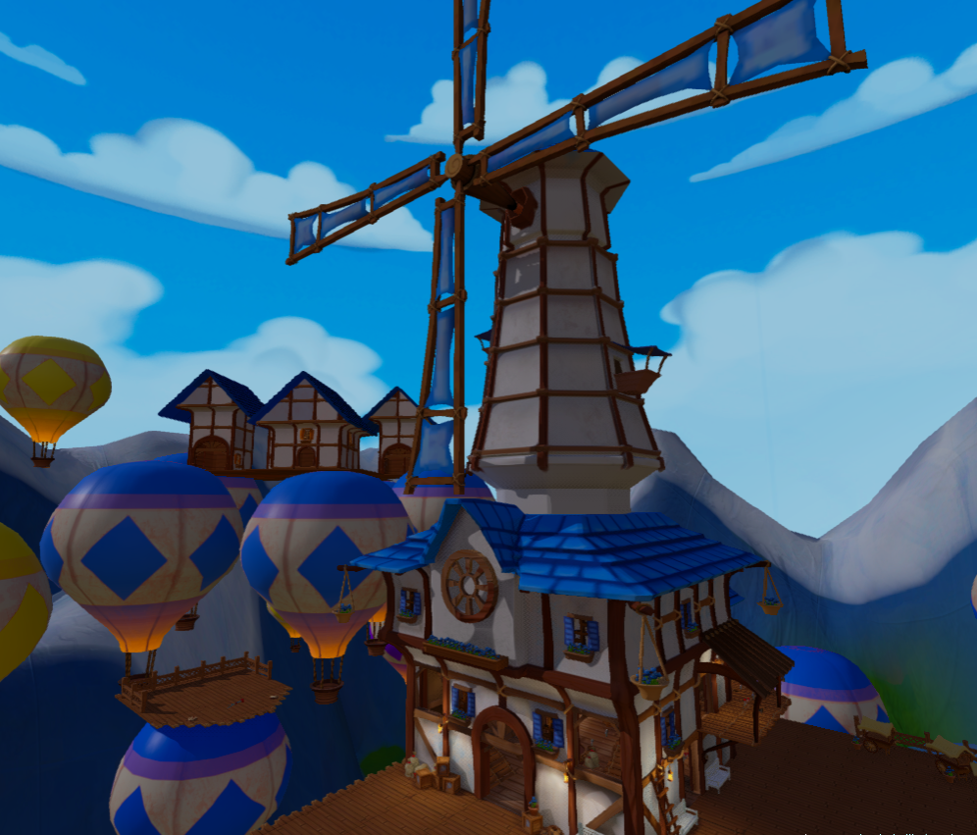
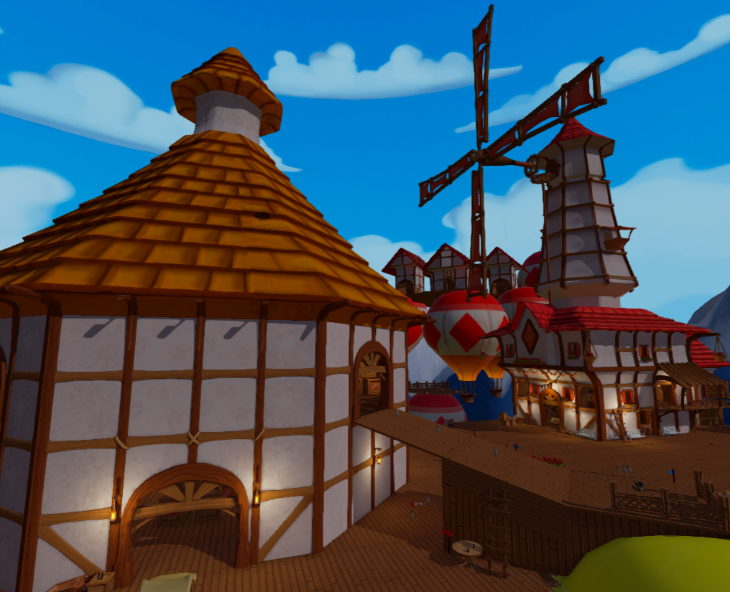
Figure 8: Buildings elements
Gameplay and decoration elements have different colors according to their position in the map. In order to signal to players their position on the map, objects in a team’s base are red or blue as is appropriate for the team. In neutral areas, these elements use neutral colors, primarily yellow which signifies the center of the map.

Key Objects
These objects are unique and exclusive to their game type and play a core role during the matches.
Name | Concept |  | Game type
Flag |  | 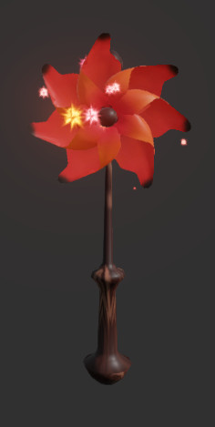 | Capture the Flag
Table 5 - Objects that define Luft's core gameplay.

Pinwheel
Pinwheels, Luft's variation of flags, are the scoring item of the Vanilla CTF game type. Each team has one pinwheel, located in their respective bases. In order to score one point, the member of a team must take the opponent’s pinwheel and bring it back to their base. A player needs to touch the opponent team’s pinwheel to hold it. If a player dies while holding the pinwheel, that player drops it on his/her current position. The pinwheel remains on that position 10 seconds and then it respawns at the base of its owner team. Other players are able to interact with the dropped pinwheel. If the player is a member from the team that owns the dropped pinwheel, the pinwheel goes back to the base instantaneously. Otherwise, that player begins to carry the pinwheel.

HUD
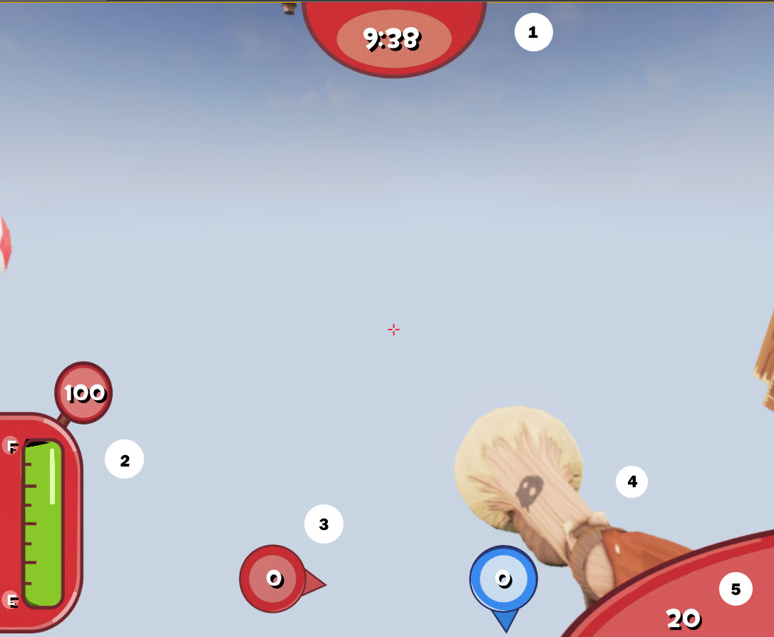
Figure 9: HUD
HUD Element ID | Description
1 | Remaining time
2 | The pressure gauge and numeric value represents the player’s health
3 | Flag indicators, which point to both team’s flag and show the current game score
4 | Player’s weapon (currently using / carried)
5 | Player’s ammunition count
Table 10: HUD Mockup Legend

Characters
Crafted from canvas and filled with hot air, “Balloon Buddies” are puffy, balloon-based humanoids. Originally designed to pilot hot air balloon rides, these adorably sweet creatures also serve as balloon trip companions. Their semi-intelligent nature allows them to move and act without assistance. However, the bouncy balloons cannot speak and retain a child-like innocence to their surroundings. When their European creators began suspending villages, the “Balloon Buddies” loyally followed to live in the clouds above. As the one hundred year anniversary of their ascent arrives, the companions prepare for a celebratory event. On behalf of their respective settlements, two “Balloon Buddy” teams must battle in “Capture the Flag” games. This friendly, non-violent competition promotes positive relations amongst the sky villages while also highlighting the glorious balloon creatures. Despite having weapons, the companions are at no risk. If popped during the festivities, the “Balloon Buddies” merely re-inflate.
Team One
The Blue team resides from the village of Bloonburg and represents this team throughout the games. Their bright, blue bodies and circle based pattern serves as a stark contrast to their opponents.
Team Two
The Red team hails from the village of Poppington and represents this team throughout the games. Their bright, red bodies and diamond based pattern serves as a stark contrast to their opponents.

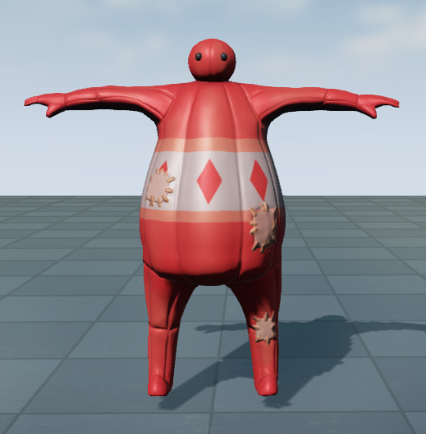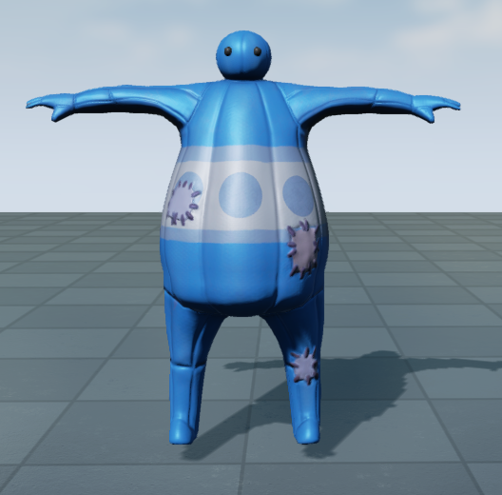
Figure 10: Team colors

World Layout

Game World Overview
There are two distinct Luft levels. Players select them from the main menu and they have no bearing on each other.

Level Descriptions

Vanilla CTF Level: Twin Windmills

Quick Summary
“Twin Windmills” is a Capture the Flag map designed for eight players, which revolves around the two windmills serving as the team’s bases, and the giant tavern, which forms the level’s atrium.
Twin Windmills - Multiplayer LDD.docx

Environment Concept
In “Twin Windmills,” both bases have two routes connecting to the central atrium. The left hand side path is a small house connecting to the tavern’s second floor. The middle path is the shortest route, taking players directly into the action. The two windmills in the center of the map are the signature of “Twin Windmills,” which creates an interesting atrium.

Vanilla CTF Level: Cloud City

Quick Summary
This level brings Luft’s unique theme into the gameplay, delivering a whimsical experience, where players feel they are fighting in floating buildings, bridges and hot air balloons. Multiple platforms, paths and jump pads create a lot of verticality and bounciness, which, combined with the map’s openness, force the players to be aware of their surroundings and use that against their opponents.

Lima_Luft_VanillaCTF_LDD.docx

Environment Concept
“Cloud City” places the players into this arena in the skies, combining clusters of hot air balloons with traditional Switzerland-like buildings, like old houses, bridges and windmills. Ropes, nets and wooden platforms either suspended by balloons or atop of them decorate and connect the different areas. In the background, players see mountains, clouds, lush green fields and other elements that characterize this kind of European environment.

Menu System
Figure 11: Menu System

Installation
Figure 12: Installer Icon
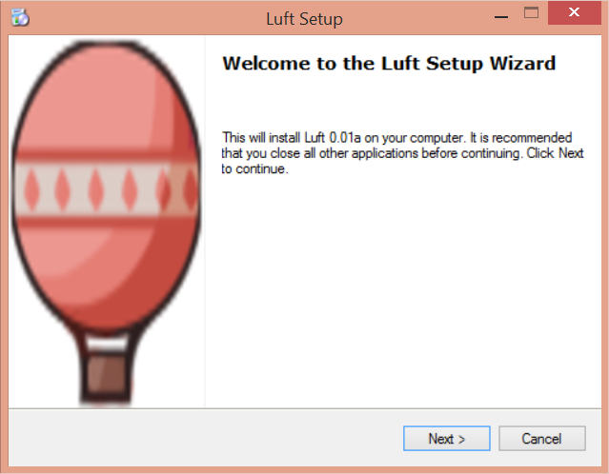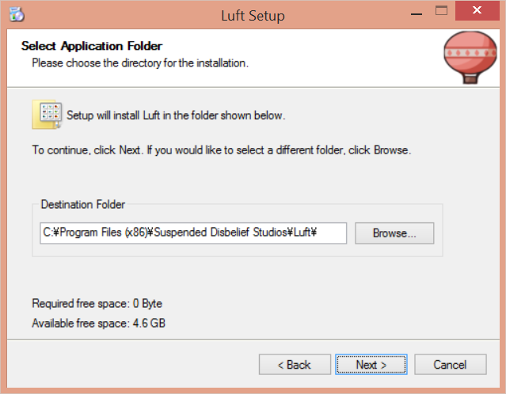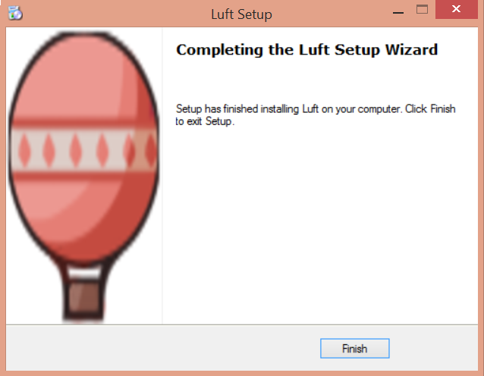
Figure 13: Luft Setup Wizard

Title Splash Screens
Figure 14: Guildhall Splash Screen
Figure 15: Unreal Splash Screen
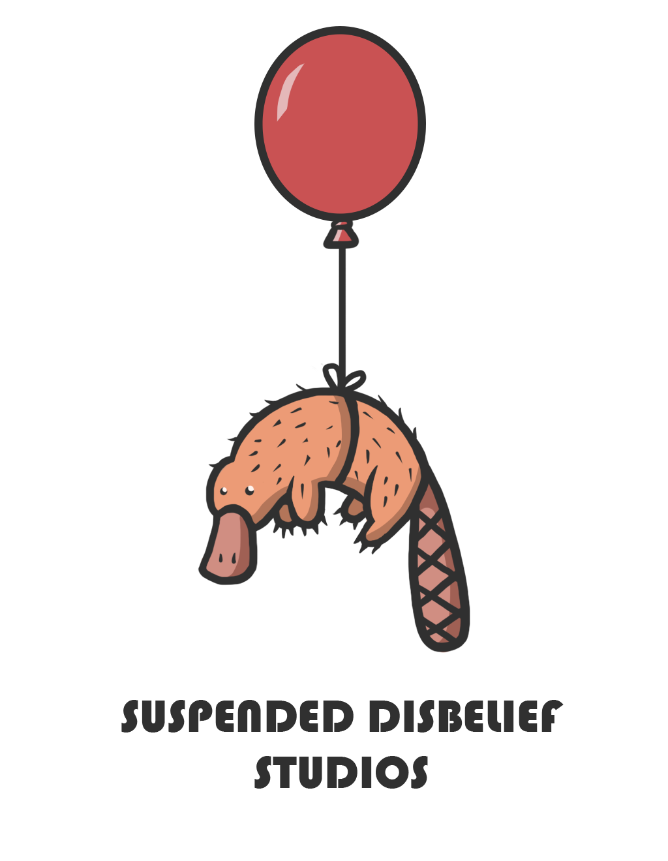
Figure 16: Suspended Disbelief Splash Screen¹

Main Menu

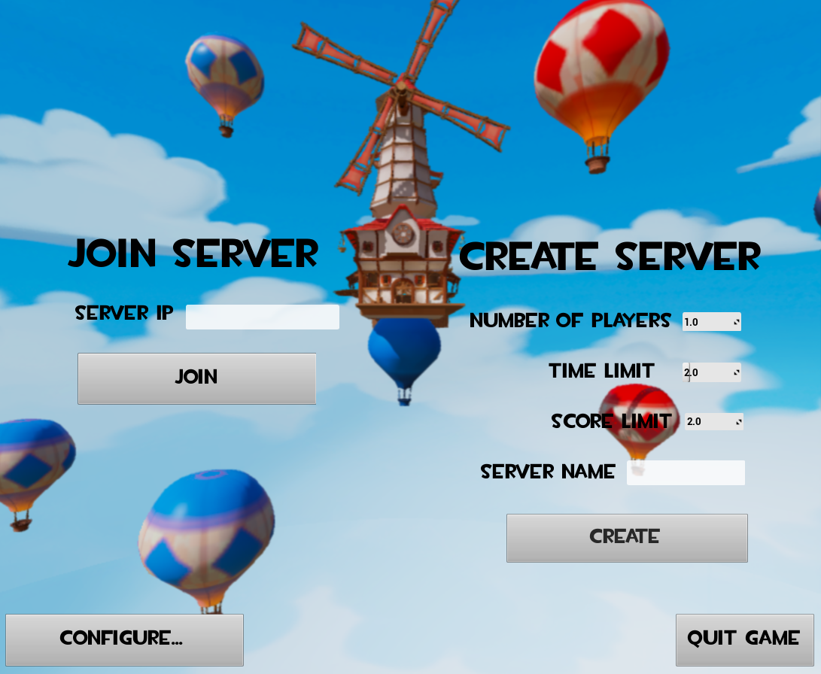
Figure 17: In Game Menu

Options Screen
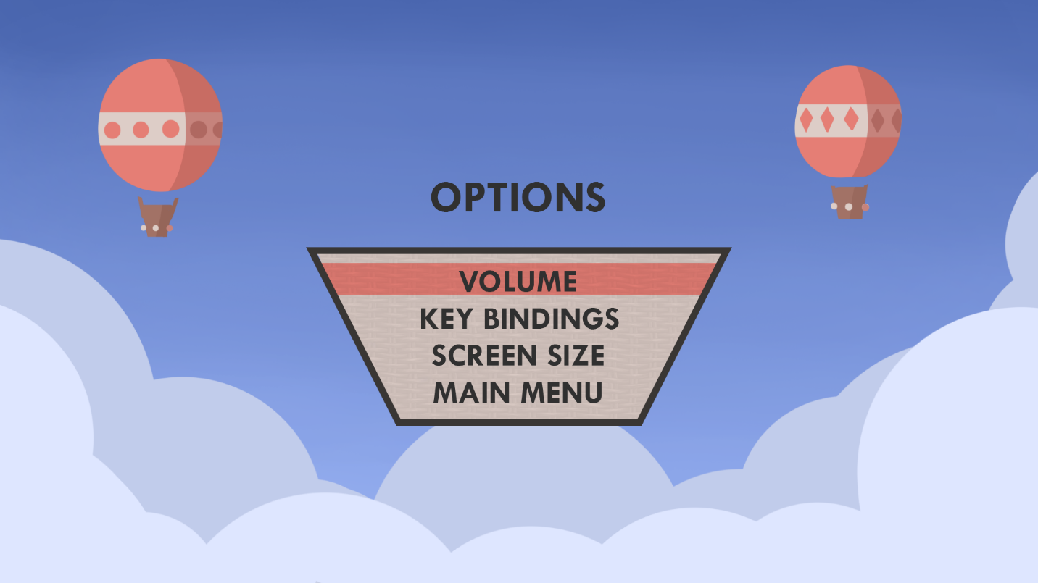
Figure 18: Options Screen
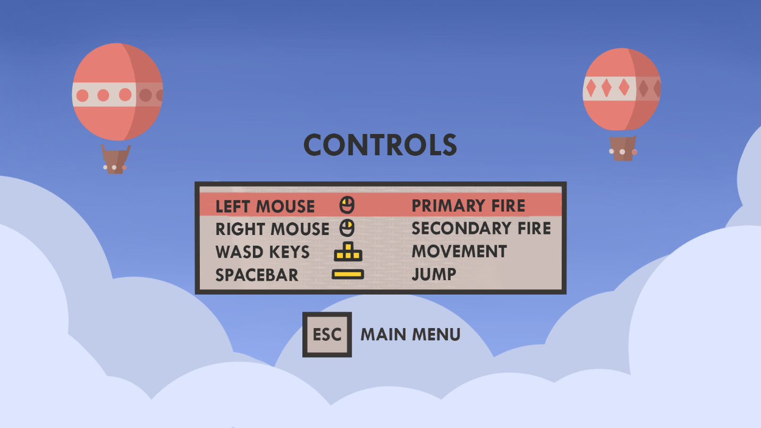
Figure 19: Controls

Pause/Exit Screen
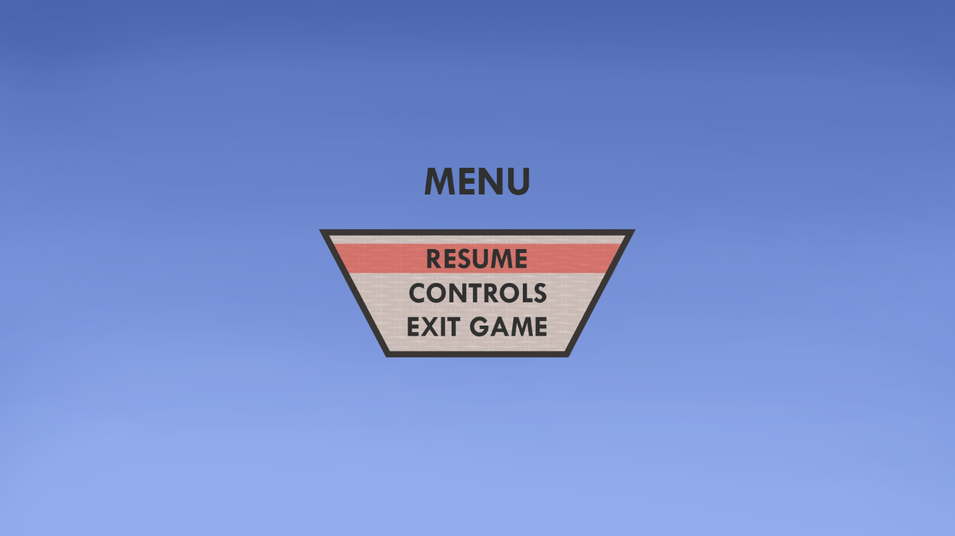
Figure 20: Pause Screen

Game Over Screen
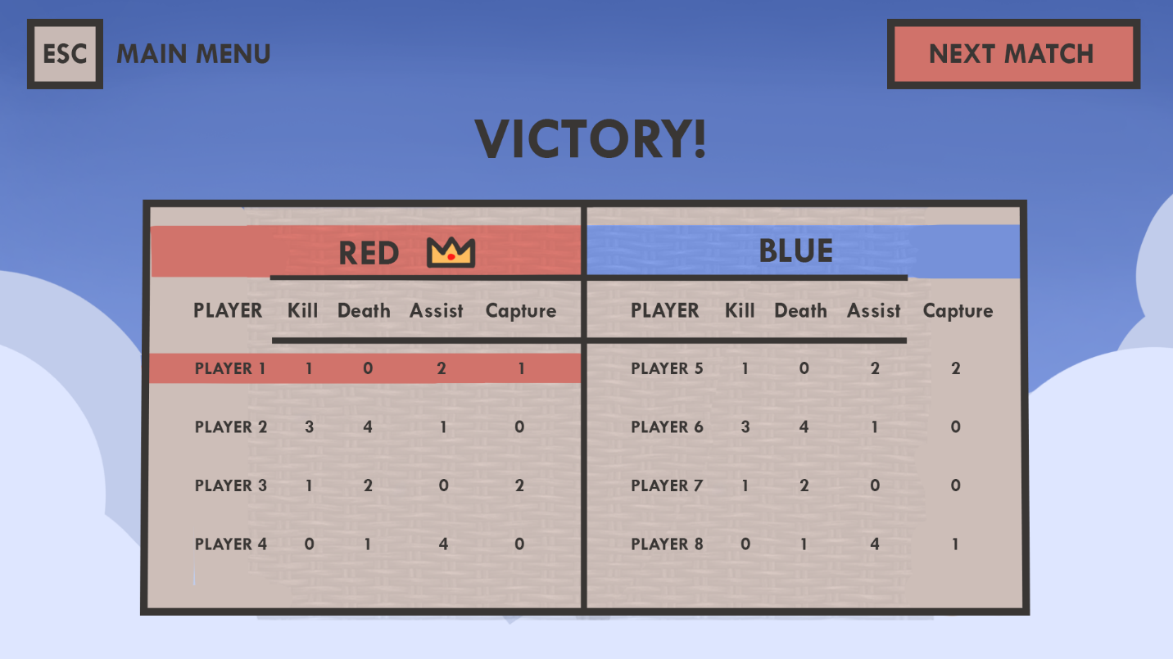
Figure 21: Victory Screen
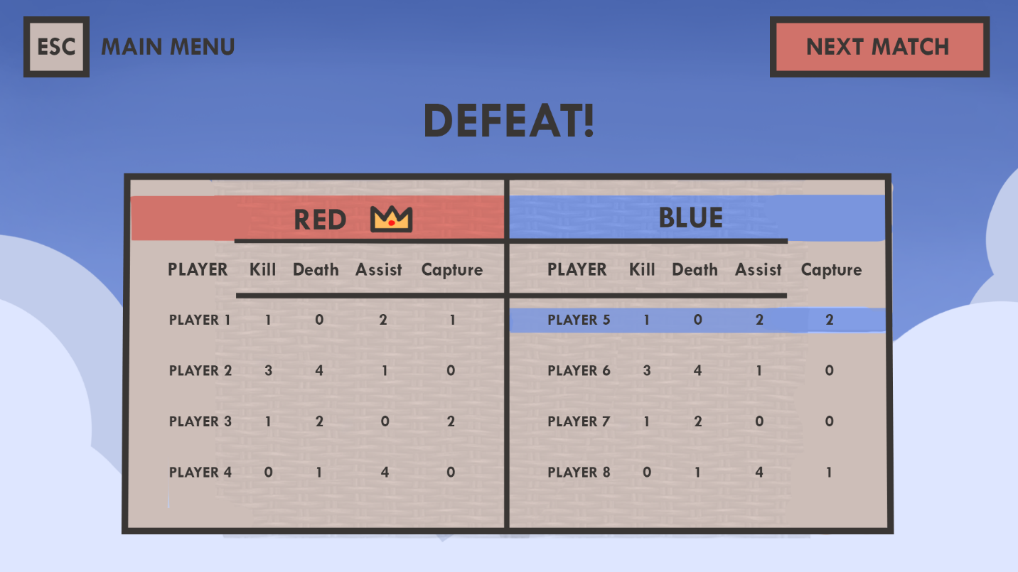
Figure 22: Defeat Screen

Credits Screen
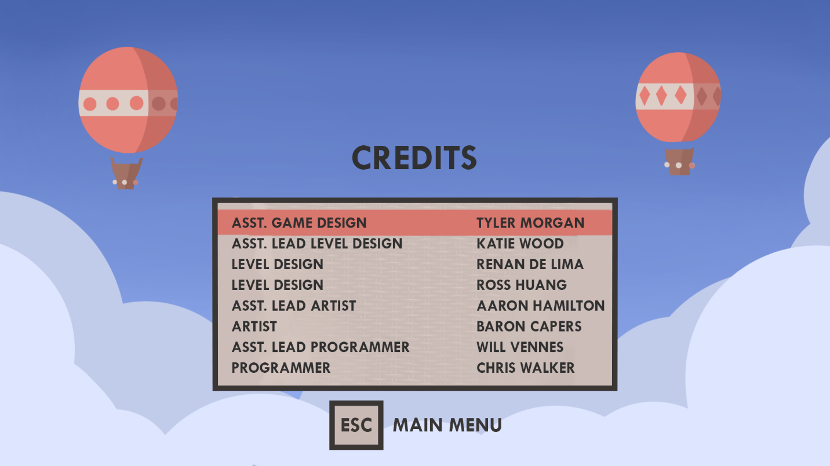
Figure 23: Credits

