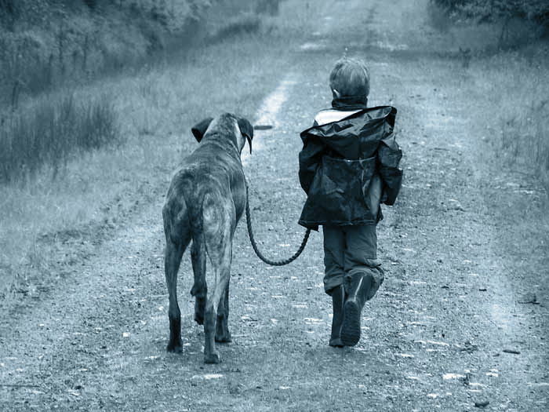
[http://petandvet.net.nz/wp-content/uploads/2012/10/boy_and_dog_kmws2.jpg]

Level Abstract: Trail of Tears
  - The Elder Scrolls V: Skyrim – Renan Lima
  - Version 1.0
Designer: | Renan Henrique Pereira de Lima
Document Date: | 11/18/2015
Intended Level Delivery Date: | 02/08/2016

Document Revisions Table
Version | Description | Requestor | Date
0.6 | Headers, Front Page, Quick Summary, and Level Summary | Professor McCoy | 11/17/2015
0.9 | Visual Themes, Key Theme References, References | Professor McCoy | 11/17/2015
1.0 | Initial Document (Complete) | Professor McCoy | 11/18/2015

Table of Contents
Table of Contents 3
Table of Figures 4
Quick Summary 5
Hook(s) 5
Gameplay Highlights 5
Mechanics 5
Gameplay style 6
Setting Summary 6
Mission Difficulty 6
Mission Metrics 6
Characters 6
Visual Themes 8
Key Theme References 8
Level Summary 10
Campaign 10
Context 10
Backstory 10
Aftermath 10
Objective(s) 10
Overview Map 11
Level Flow 11
Flow Summary 11
Level Breakdown 13
The Farm: Beginning 13
On the Mountains 14
Forgotten Cave (1) 15
Forgotten Cave (2) 16
The Farm: End 17
References 19

Table of Figures

Figure 1: References for the farm: countryside, pinewood forest, snow, different day times [1,2, 3 … 7]. 8
Figure 2: References for the mountains: blizzard, heavy snowfall, night time [8,9 …, 12]. 9
Figure 3: References for the forgotten cave: Dwemer ruins, ice caves, waterfall [13, 14, …, 21]. 9
Figure 4: Overview Map (exteriors). 11
Figure 5: Overview Map (interiors). 12
Figure 6: Detailed section: The Farm – Beginning. 13
Figure 7: Detailed section: On the Mountains. 14
Figure 8: Detailed section: Forgotten Cave (1). 15
Figure 9: Detailed Section: Forgotten Cave (2). 16
Figure 10: Detailed section: The Farm – End. 17

Level Abstract

Quick Summary
“Trail of Tears” is a single-player, 3rd person-perspective, side quest level for The Elders Scrolls V: Skyrim (PC), which provides an exploration-based gameplay different from the original game. In this level, players take the role of Ixion, a brave farm boy, followed by his faithful dog companion Reus, in their emotional journey to survive the threats of wild nature. Traversing hostile scenarios such as Nordic mountains, ice caves and Dwemer ruins, players need to combine the abilities of both characters in order to make it back home.

Hook(s)
“Trail of Tears” has the following hooks:
- Innovative, non-traditional, gameplay style based on the cooperation between Ixion, the boy, and Reus, the dog
- Unique emotional experience, as players tend to feel guilty about their actions throughout the level

Gameplay Highlights

Mechanics
Players are able to control Ixion directly, walking/running and jumping around with him. However, they are not able to attack at all. In addition, they can interact with elements in the environment by pressing ‘E’, as well as, command Reus using mouse buttons. The dog has two different behaviors, according to its combat state:
- When not in combat:
  - General behavior: Reus generally follows Ixion around
  - Left mouse button: Reus explores the area, stopping by any interesting element within a certain range: traps, chests, and, ambushes
  - Right mouse button: if pressed after left mouse button, Reus either triggers the found trap or anticipates the ambush, engaging combat with enemies. If pressed before left mouse button
- When in combat:
  - General behavior: Reus fights the closest enemies, protecting Ixion, but not necessarily following him. However, if Ixion’s health is too low, the dog comes around him to protect the boy, regardless of any player input
  - Left mouse button: Reus goes near Ixion’s current position, holding it for a while. After that, it reassumes general behavior
  - Right mouse button: Reus barks, taunting the enemies and drawing their attention. After that, for a while, they stop attacking Ixion, completely focusing on the dog
As an NPC, Reus cannot die throughout the game. The companion can get very hurt, walk slowly and limping. After a while, it recovers health progressively. However, in the end of the level, the dog cannot survive the last threat and ends up dying.

Gameplay style
This level’s core gameplay style combines exploration and cooperation between Ixion and Reus. As players do not have any means to attack, they must rely on Reus to survive the threats (traps and enemies). However, using the companion to find traps, for example, can potentially hurt it. As previously said, players are also able to interact with environmental objects (such as levers and buttons), to open doors/gates and activate traps. This way, they can use Reus as bait, luring enemies into traps, though, putting the dog in danger. Furthermore, this level forces players to take tough decisions and feel sad and guilty about their actions.

Setting Summary
Theme | Fantasy, Companionship, Sacrifice
Mood | Guilty, Sadness, Emotional attachment
Setting | Medieval Fantasy, Farm, Pinewood Forest, Snowy Mountains, Dwemer Ice Cave
Time of Day | Dusk (Farm), Night (Farm, Mountains, Dwemer Ice Cave), and Morning (Farm again)
Season | Transition from Fall to Winter
Weather | Snowy weather (mostly)

Mission Difficulty
Position | Difficulty | Reasons
Beginning | 3 | Learning a reasonable amount of mechanics
Middle | 5 | Applying recently learned mechanics to non-friendly contexts
End | 6 | Slightly more complex puzzles
Scale: 1-10 (1 is Easiest and 10 is Hardest)

Mission Metrics
Play Time | 30 minutes
Critical Path | 471.5m
Physical Area | (Width x Height)  The Farm (exterior): 58.5m x 58.5  On the Mountains (Exterior): 25.6 x 52.18m  Forgotten Cave 1 (Interior): 84.09m x 84.09m  Forgotten Cave 2 (Interior): 51.18m x 25.6m

Characters
Character | Description
Ixion | Ixion is the level’s playable, main character. He is a 12-year old boy, living in a farm with his parents (Adam and Eva) and his friend Reus, the dog. Although he does not have any fighting skills, the boy is very smart and strong. He is always helping his dad with farm duties, followed by Reus.
Reus  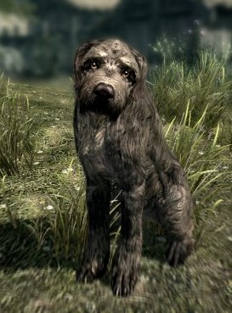  [http://skyrimfansite.com/wp-content/uploads/2013/10/Dog-As-A-Skyrim-Companion.jpg] | Reus is an NPC dog who follows the main character throughout the level. Inseparable friend of Ixion, this dog is always by his side. Used to assist Ixion and his family with farm tasks, Reus is very helpful to find items, traps, and even, enemies.
Adam (Dad) | Adam is an ally NPC. He is Ixion’s dad and very protective to his family. As a farmer, he is mainly responsible for raising cattle and selling farm byproducts in the village. He has taught Ixion many tricks to play with Reus.
Eva (Mom) | Eva is another ally NPC. She is Ixion’s mom and the family’s manager. She takes care of the cabbage plantation, as well as, the ‘boys’ (Adam, Ixion, and Reus). Although she says not to like dogs, she loves Reus as much as the others do.
Cave Bear  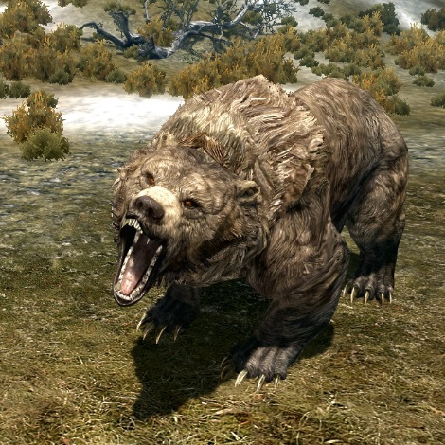  - [http://images.uesp.net/6/60/SR-creature-Cave_Bear.jpg] | The cave bear is “Trail of Tears” main enemy. Although it does not characterize as a villain, this wild beast is responsible for killing Adam, as well as, for threatening Ixion and Reus to protect its territory. It chases the main character throughout the level.
Cave enemies | These minor enemies ambush Ixion and Reus in the Dwemer caves. Ranging from Dwarven Spiders to Dwarven Spheres, they are not evil as their intention is only to protect their territory.

Visual Themes
Theme | Description
The Farm | Exterior, countryside area surrounded by pinewood forest and mountains. It has farm tools and buildings (such as barns), as well as, cattle, plantation, etc. For both beginning (morning light) and end (dusk), it feels calm, quiet, and cozy. For the transition (night time), the area maintains those aspects, with a little bit of eerie added to it.
On the Mountains | Exterior, a lot of snow throughout the path, surrounded by mountains. Night time combined with the blizzard gives this area a sense of danger and inquietude, foreshadowing the tragedy about to happen.
Forgotten Cave | Interior, ice cave combined with Dwemer ruins. Usual dim light, very weary, full of Dwarven pipes, spider webs, ice blocks, debris, etc. However, it still has functioning structures, making it feel unsettling

Key Theme References
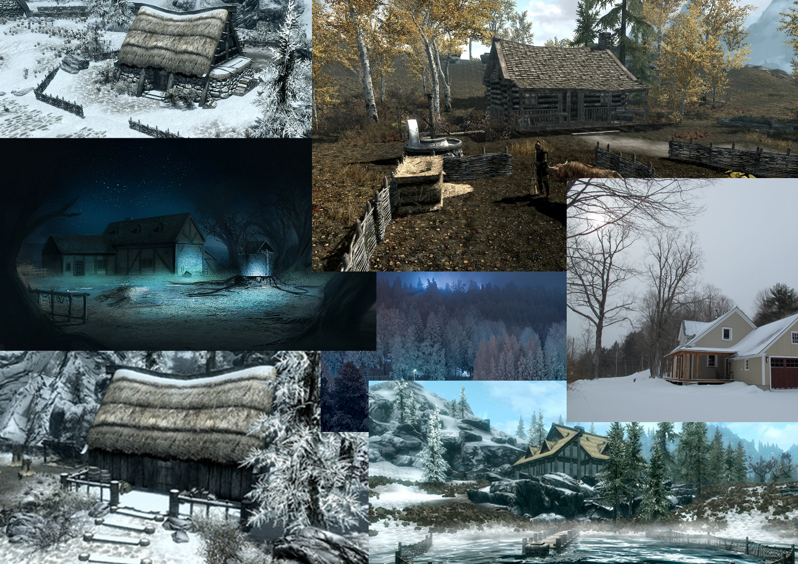
Figure 1: References for the farm: countryside, pinewood forest, snow, different day times [1,2, 3 … 7].

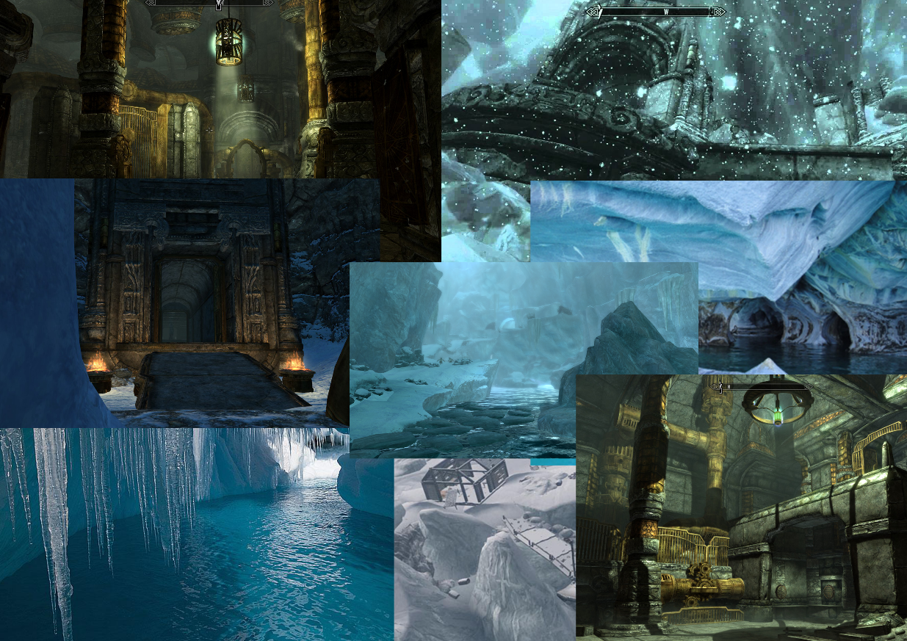
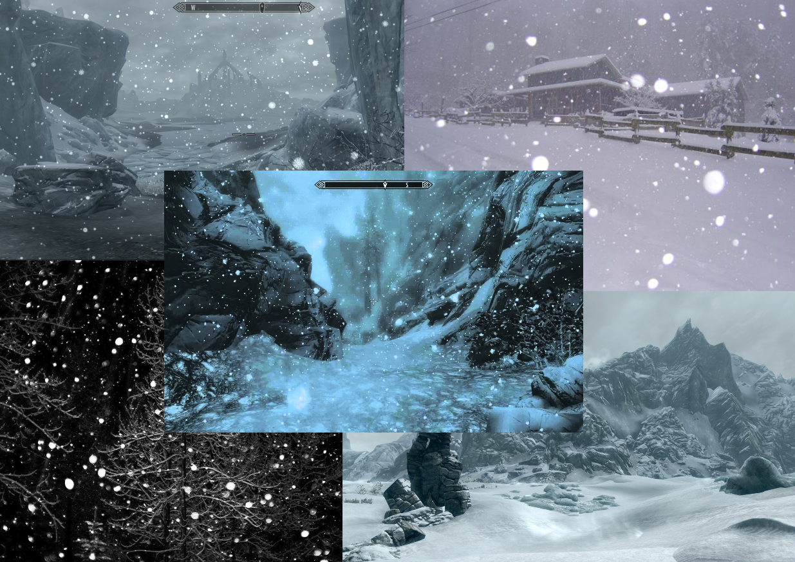
Figure 2: References for the mountains: blizzard, heavy snowfall, night time [8,9 …, 12].
Figure 3: References for the forgotten cave: Dwemer ruins, ice caves, waterfall [13, 14, …, 21].

Level Summary

Campaign

Context
“Trail of Tears” is a side level in the Skyrim universe and does not relate to the title’s main campaign. This level can take place at any point of the game’s story, as it does not involve its original main character (Dragonborn). In this regard, the world of Skyrim serves the purpose of providing a context for the Ixion’s and Reus’ emotional journey.

Backstory
Considering the aforementioned context, as Ixion, players start “Trail of Tears” in the boy’s farm, more specifically, in his house. After engaging situations where they learn the level’s core mechanics, such as finding ingredients for his mom’s recipe and helping his dad against the wild wolves, they experience Ixion’s tale (level’s biggest section).

Aftermath
After losing Reus and getting out of the Dwemer cave, Ixion follows the river trail to go back home. There, he finds his mom desperate thinking her husband and son were dead. Despite the sadness of losing Adam and Reus, Eva cheers up meeting her son again. Finally, they both move on with their lives.

Objective(s)
“Trail of Tears” has two major objectives:
- Survive the journey and return home, overcoming obstacles and threats – traps, and enemies
- Get out of the ruins. This includes:
  - Help Eva (mom), finding ingredients
  - Help Adam (dad), tracking the lost cattle and fighting wolves
  - Finding shelter after the bear’s attack
  - Solving puzzles utilizing Dwemer mechanisms to open gates and unlock doors
  - Using Reus to sniff important elements in the environment
  - Using Reus as a bait to lure enemies
  - Hurting and sacrificing Reus to kill the bear

Overview Map
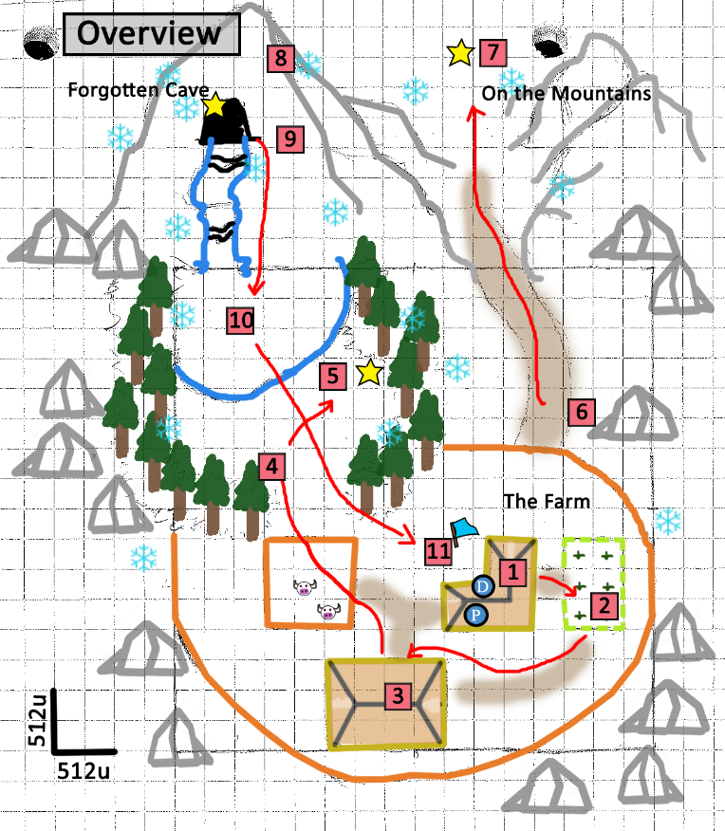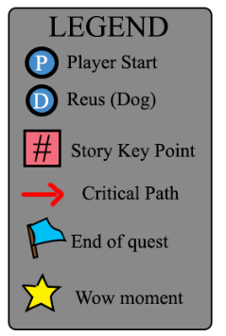
Figure 4: Overview Map (exteriors).

Level Flow

Flow Summary
- Introduction: Players start the level in Ixion’s house. They meet Reus and Eva (Ixion’s mom)
- Tutorial 1:Players have their first tutorial about Reus’ non-combat behavior (finding items), looking for ingredients that Eva asked for
- Tutorial 2: After going back to the house to bring the ingredients back to Eva, players meet Adam (Ixion’s dad). Then, along with Reus, they follow Adam to the warehouse, where they have the second tutorial (about Reus’ non-combat behavior – finding traps), while dad prepares them to look for wild wolves that attacked the cattle
- Tutorial 3: Into the woods, players go with Adam, looking for the wolves. They find the first one and have the first tutorial about Reus’ combat behavior (bark to taunt enemies). Moreover, they have their first exposition to using traps to lure enemies
- Tutorial 4: Proceeding, they find two more wolves. This serves the purpose to teach them about Reus’ combat ability to go to Ixion’s location and hold it for a while. With this, they defeat the beasts
- Transition: late at night, players meet Ixion’s mom and dad in the farm’s exit, before they leave with Adam to the town village. Then, Ixion and his dad leave, Reus following them
- Turning point/call to action: on the mountains, a wild bear attacks the group. Players have to run away, hiding in a secret cave (Forgotten Cave) with Reus. The bear kills Adam
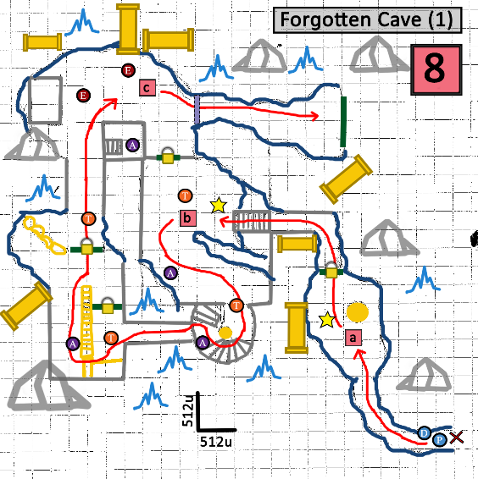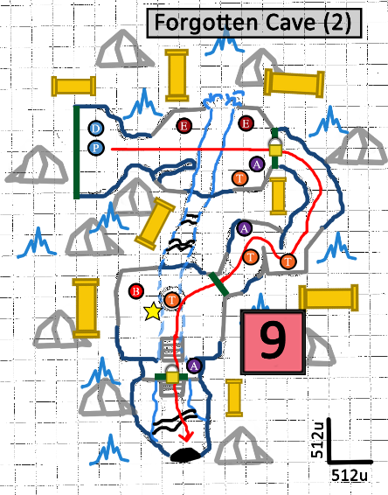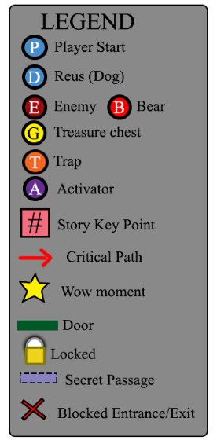
Figure 5: Overview Map (interiors).
- Development: Players get trapped in the ruins and have to find their way out:
  - Bear attacks Ixion and Reus, causing ice and stones to fall and trap them
  - Players need to go through a series of traps and enemies, trying to get out alive. Throughout this process, they must use Reus abilities, very likely, hurting the dog (Guilt moments)
  - As the level advances, there are more situations demanding Reus support (Guilt moments)
- Climax: players encounter the bear again in the last room, where they have to sacrifice Reus to kill the beast and escape the cave through a cave’s internal river, realizing they were looping back to the farm (WOW Moment)
- Conclusion (part 1): Players jump from the waterfall to the lake, heading towards Ixion’s home
- Conclusion (part 2): Finally, they meet Eva (Ixion’s mom) again, relieved to see her son alive

Level Breakdown

The Farm: Beginning
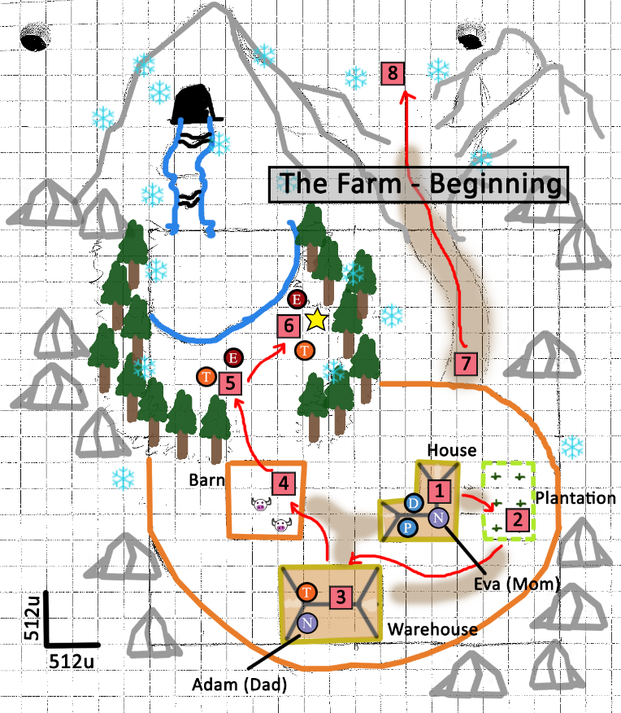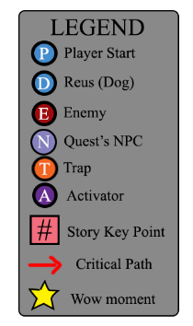
Figure 6: Detailed section: The Farm – Beginning.
- Reus barks, waking up players. Ixion’s mom talks to them, asking for a couple of different ingredients outside, so she can finish the meal for their travel. Eva also tells players to use Reus’ great sniffing abilities to find them (Tutorial 1 – teaching Reus’ non-combat behavior – items)
- Players go outside and Reus helps them finding the ingredients in different locations. They bring the ingredients back to Eva. Adam enters the house, saying that wolves attacked the cattle again and he needs Ixion’s help to find the beasts
- Players follow Ixion’s dad outside the house, to the warehouse. There, dad tells them about possible traps on the way and about how to tell Reus to detect them (Tutorial 2 – teaching Reus’ non-combat behavior – traps)
- Then, players move to the Barn, where they see dead cattle and a trail of blood leading to the forest. From there, they follow Adam deep into woods
- In the forest, they find a first wolf, and face it along with Reus and Ixion’s dad. Adam explains to them how Reus can bark to taunt enemies. There, they also use Reus to detect and activate traps. After, Adam kills the wolf and they proceed (Tutorial 3 – teaching Reus’ combat behavior – taunt)
- Next to the lake, players find two more wolves. This time, Adam is not able to kill them because he is outnumbered. He explains players they need to use Reus as a bait to lure the wolves into a nearby trap. Players successfully do that, killing the beasts (Tutorial 4 – teaching Reus’ combat behavior – holding position). Adam tells them to hurry back, as that night they go to the town village to sell their products
- At night, Adam, Ixion, and Reus say goodbye to Eva and begin their journey. Even with Ixion’s dad saying that Reus cannot go; the dog finds its way to follow them. Players can walk around and talk to the NPCs

On the Mountains
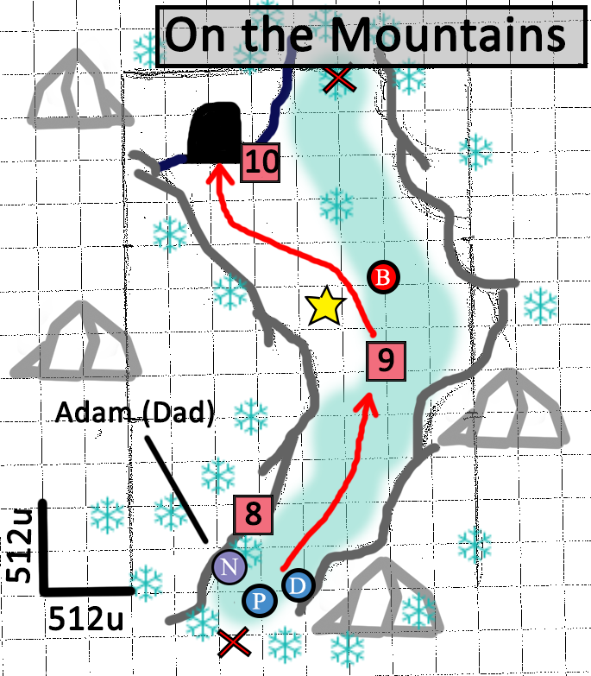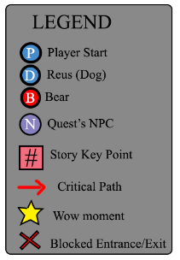
Figure 7: Detailed section: On the Mountains.

- On the mountains, it is snowing very strongly and Adam decides to stop and find a shelter. Players follow him, along with Reus. Blizzard winds prevent them from getting out of the playable space
- As they walk, a giant bear attacks them. The bear focuses on Adam and Reus. Players walk around and use Reus abilities, but they cannot harm the bear. Adam tells them to look for a place to hide, while he keeps the bear distracted
- Players explore the area and find a cave entrance. They get in, followed by Reus – the fight between Adam and the bear does not stop

Forgotten Cave (1)
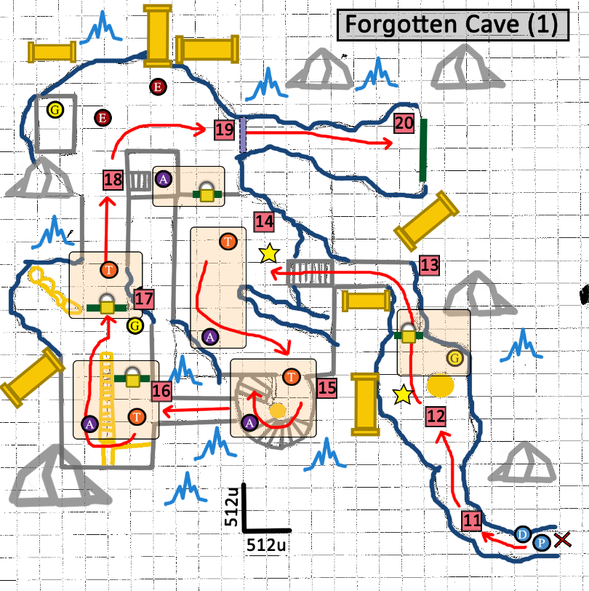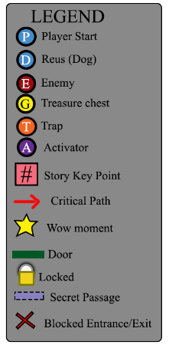
Figure 8: Detailed section: Forgotten Cave (1).

- Right after they get into the cave, the bear follows them, forcing players to run deeper into the cave – so far, the scenario is mostly ice and stones, with some old excavation tools
- Once players go to a larger area, the bear stumbles against the area entrance, too big to get in. Because of that, stones and ice fall from the ceiling, blocking that path (WOW Moment). Players start exploring the area, trying to find their way out
- Then, players find a locked door. They can use Reus to find a hidden chest, containing the door’s key and progress
- Players walk up the stairs, realizing they are actually in Dwemer ruins (WOW Moment). In that area, there is a locked door – its opening mechanism resides in other room – a trap, with its sensor and activator. Players need to be careful, but not necessarily use Reus to avoid the trap
- Going to the next room, there is another trap, which players cannot avoid. They have to either trigger it themselves (getting hurt), or use Reus to do it, hurting the dog (Guilt Moment). Down the stairs, players can use the activator to experiment and trigger the trap again
- The following area has another locked access. However, players can jump over some debris and go around the gate – something that Reus cannot do*. They can use an activator on the other side to open the locked access. However, this triggers a trap, damaging the dog (Guilt Moment)
*if players decide to, they can try to progress without Reus, but the next challenge prevents them from succeeding
- This section has a chest containing health items that players can use to heal Ixion, but not Reus. Ongoing, players cannot proceed, as there is another locked gateway. On the side, there is a hole large enough so Reus can move through. Players must use Reus’ abilities to activate a trap in the next room that also opens the gate. This trap, though, does not hit Reus
- Then, players advance to a larger area of the map. They can use Reus to find a hidden chest with healing items and to detect the eminent ambush (Dwarven spiders). This area’s activator opens the gate connecting it to one of the already visited rooms. Players can either rely solely on Reus combat to kill the enemies or use the dog’s abilities to lure them into some nearby trap
- After the combat, players need to use Reus to track a secret passage and proceed to the next area
- Players and Reus transit to the next area (going down into the ruins)

Forgotten Cave (2)
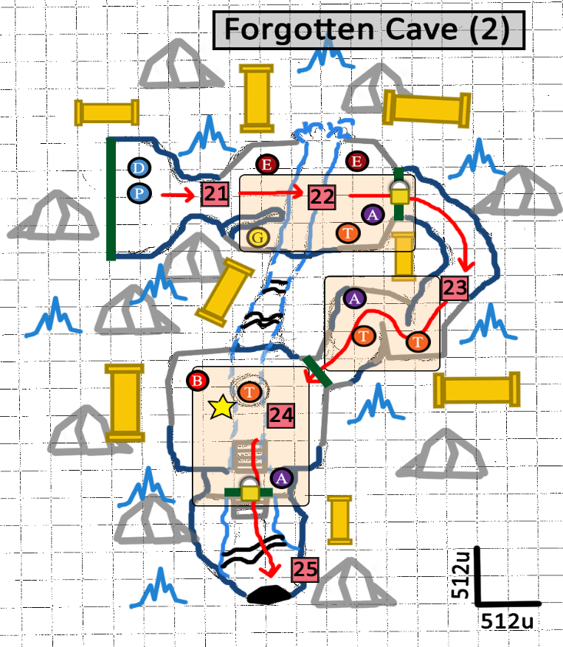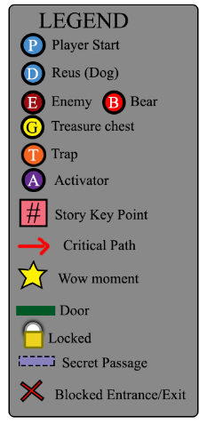
Figure 9: Detailed Section: Forgotten Cave (2).
- Deeper in the cave, they see a river flowing below the old structures. Players also find the next door locked. If they try to use the activator nearby, they trigger a trap, hurting them and/or Reus – depending on their positioning*. In this case, players have to use Reus to find the door’s key
* Players can use Reus to detect the trap nearby
- Once they reach the key, two enemies ambush them* (a Dwarven sphere and a Dwarven spider). Along with Reus, players can use the activator to damage enemies – but possibly also hurt Reus (Guilt Moment)
* Players can use Reus to prevent the ambush
- After killing enemies and opening the door, players move to the next area: corridors with a couple of dangerous traps. Although it is not required, players have a higher chance of survival if they use Reus to detect traps. There is also an activator that allows them to trigger traps to kill any remaining enemies
- Players advance to the level’s climax: they enter into a larger area – which is also above the river – and find the giant wild bear, which attacks them again (WOW Moment). The door to the previous corridors locks and the other one available is inaccessible as well. However, players can see a line connecting it to a platform. Next to the locked door, there is also an activator. When players use it, golden bars raise, creating a kind of cage, followed by spears that pierce whatever is inside (trap).
After realizing they have to use the trap to kill the bear, players take a while to understand that using Reus as a bait is the only way to keep the beast enough time in the trap area, in order to activate the trap effectively. Then, they do it, piercing both dog and bear (Guilt Moment). They both die, their blood flows through tubes, opening the so far locked gate
- With the gate open, players, now alone, go to the next area, which is flooded. They jump into the cold water, exploring the area and finding an exit from the cave

The Farm: End
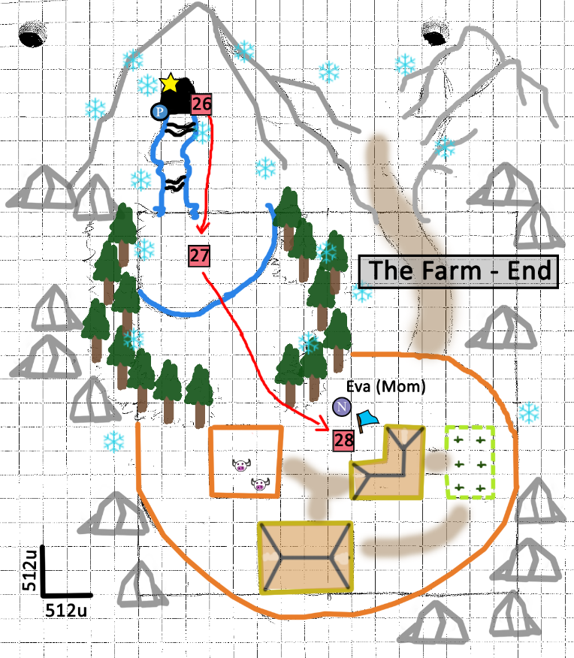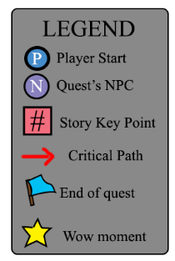
Figure 10: Detailed section: The Farm – End.

- Out of the cave, they see Ixion’s farm, the forest, and mountains around it (WOW Moment)
- They jump down into the lake, heading towards home
- Finally, players go through the woods and get near Ixion’s home. There, they find Eva who hugs them (Ixion), relief to see her son back again. She explains that people found Adam’s dead body in the mountains and assumed Ixion was dead too. So, although Reus’ death was also tragic, she felt happy for meeting her son again (Level End)

References
- http://vignette2.wikia.nocookie.net/elderscrolls/images/c/ce/Merryfair_Farm.jpg/revision/latest?cb=20111203061809
- http://img3.wikia.nocookie.net/__cb20121113223519/elderscrolls/images/thumb/b/b5/Brandy-Mug_Farm.png/500px-Brandy-Mug_Farm.png
- http://www.primagames.com/media/files/elder-scrolls-skyrim-legendary-eguide/slg07-001.jpg
- https://farm3.staticflickr.com/2790/4350325149_96f9027934_z.jpg?zz=1
- https://www.google.com/url?sa=i&rct=j&q=&esrc=s&source=images&cd=&ved=0CAQQjBxqFQoTCIHw8qetmckCFcUrJgodvd0D4Q&url=http%3A%2F%2Fwww.cartoontreasure.com%2Fpic_content.php%3Fpic_id%3Dfantasy-night-well-free-desktop-wallpaper&bvm=bv.107763241,d.eWE&psig=AFQjCNHcV5h178RdSHe_fJ-0EPkotwtcMQ&ust=1447914751600901&cad=rja
- http://www.primagames.com/media/files/elder-scrolls-skyrim-legendary-eguide/slg07-001.jpg
- http://www.resilientdesign.org/wp-content/uploads/2015/01/Snowstorm_1-27-15_3865_MedRes.jpg
- https://americaridesmaps.files.wordpress.com/2009/12/blizzard.jpg
- https://chrismartinphotography.files.wordpress.com/2014/04/night-snow-c2a9-christopher-martin-437078.jpg
- http://images4.alphacoders.com/202/202878.jpg
- https://i.ytimg.com/vi/-3b8x_3n7vI/maxresdefault.jpg
- http://forum.rpg.net/showthread.php?601376-Skyrim-Screen-Shot-Thread/page7
- https://i.ytimg.com/vi/iUWWgw2njxU/maxresdefault.jpg
- http://img1.wikia.nocookie.net/__cb20111124091122/elderscrolls/images/2/23/Alftand1.jpg
- http://media.moddb.com/images/members/1/339/338028/tes5_skyrim_103.jpg
- http://media.moddb.com/images/members/1/339/338028/tes5_skyrim_103.jpg
- http://static-4.nexusmods.com/15/mods/110/images/17441-1-1337622963.jpg
- http://img4.wikia.nocookie.net/__cb20120806235252/elderscrolls/images/a/ab/Glacial_Crevice.png
- http://i.imgur.com/eNAWJ.jpg
- http://orig12.deviantart.net/e85a/f/2012/117/e/c/dwemer_ruins_screencap_by_sofdmc-d4xsyz3.jpg

